## **Hi-Bridge: Comprehensive Product Requirements Document (PRD)**

**Version:** Beta 1.0  
 **Owner:** Ananth Mepperla

### **1. Executive Summary**

Hi-Bridge is a hybrid work engagement platform designed to increase in-office participation through behavioral incentives, team coordination, and manager support tools. Unlike traditional HR systems that merely track attendance, Hi-Bridge activates hybrid work policies using gamification, rewards, and real-time engagement insights.

The platform helps enterprises maximize the value of their office spaces, drive employee engagement, and reduce attrition, ultimately leading to improved business performance and cost savings.

### **2. Market Research & Impact Metrics**

* **33% lower quit rates** with structured hybrid work (Nature, 2024)
* **62% thriving well-being** in hybrid vs. 50% in-office (Gallup, 2024)
* **24% productivity boost** when employee well-being is supported (Gartner, 2024)
* **$11,000 per employee/year** saved via hybrid optimization (BCG, 2024)
* **28% less burnout** in hybrid vs. full-time office models (McKinsey, 2024)

### **3. Goals**

#### **Business Goals**

* Increase average days in-office per employee.
* Enhance employee engagement, collaboration, and innovation.
* Provide actionable insights to HR and leadership.
* Justify office space investments with utilization data.
* Improve retention and reduce attrition by up to 33%.
* Build a scalable, enterprise-ready platform.

#### **User Goals**

* **Employees:** Want fairness, choice, and incentives for in-office participation.
* **Managers:** Seek better visibility into team collaboration and well-being.
* **HR:** Desire transparency on policy compliance without micromanagement.
* **Companies:** Aim for cost savings, productivity gains, and improved morale.

### **4. User Personas, Use Cases & User Stories**

#### **User Personas**

* **The Empowered Manager:** Mid-level team leader needing tools to boost team cohesion and track engagement.
* **The Engaged Employee:** Individual contributor seeking fairness and connection.
* **The Strategic HR Leader:** People Ops leader wanting clear metrics and compliance without micromanagement.
* **The Remote Outlier:** Employee based remotely needing inclusive policy treatment.

#### **Use Cases**

* **Manager:** Sets anchor days, leads check-ins, reviews sentiment.
* **Employee:** Votes on in-office days, earns points.
* **HR Leader:** Monitors participation and morale trends.
* **Remote Worker:** Engages through virtual tools, marked as exempt.

#### **User Stories (MVP Launch Only)**

| **As a...** | **I want to...** | **So that I can...** |
| --- | --- | --- |
| Manager | Set team anchor days | Align my team’s in-office collaboration |
| Manager | View team pulse check dashboards | Identify morale issues early and take action |
| Employee | Vote on preferred in-office days | Influence scheduling and feel heard |
| Employee | Complete daily pulse checks | Share feedback and help improve team experience |
| HR Leader | Track participation trends and engagement metrics | Evaluate hybrid policy effectiveness |
| HR Leader | Configure default policy templates | Offer structure while allowing manager flexibility |

### **5. Product Capabilities & Customization**

#### **Core Capabilities**

* **Team anchor days and scheduling**
* **Daily pulse checks**
* **Gamified attendance rewards**
* **Heatmaps and engagement dashboards**
* **Calendar and SSO integrations**

#### **Customization and Flexibility**

* Default configurations + policy overrides
* Team-specific schedules and role-based rules
* Manager autonomy with corporate controls
* Compliance support for U.S. labor laws

### **6. Beta Strategy: The Hi-Bridge Games**

#### **Overview**

* Limited beta in Dallas area (2–3 weeks)
* Manager-created teams compete on participation metrics
* Goal: Gather data, create momentum, and validate MVP

#### **Format**

* Point system tied to feature use and collaboration
* Public leaderboard
* Bonus points for team engagement (e.g., in-office photos)

#### **Sponsorship**

* Local businesses provide prizes (e.g., pizzas, discounts)
* Hi-Bridge promotes partner brands to users
* Partnership models: Free items or partial team credits

#### **Why It Matters**

* Real-world proof of product outcomes
* Stimulates local economic activity
* Drives 70%+ target participation rate for pilot

## **8. MVP Screenshots**

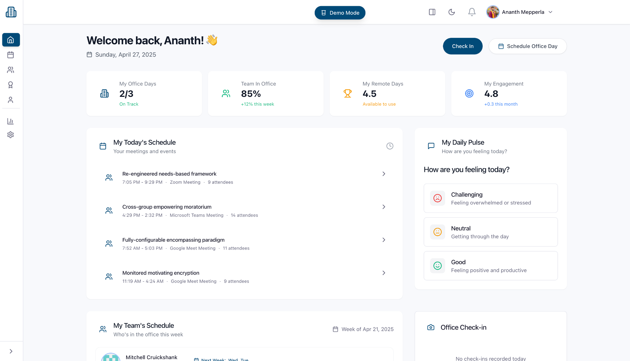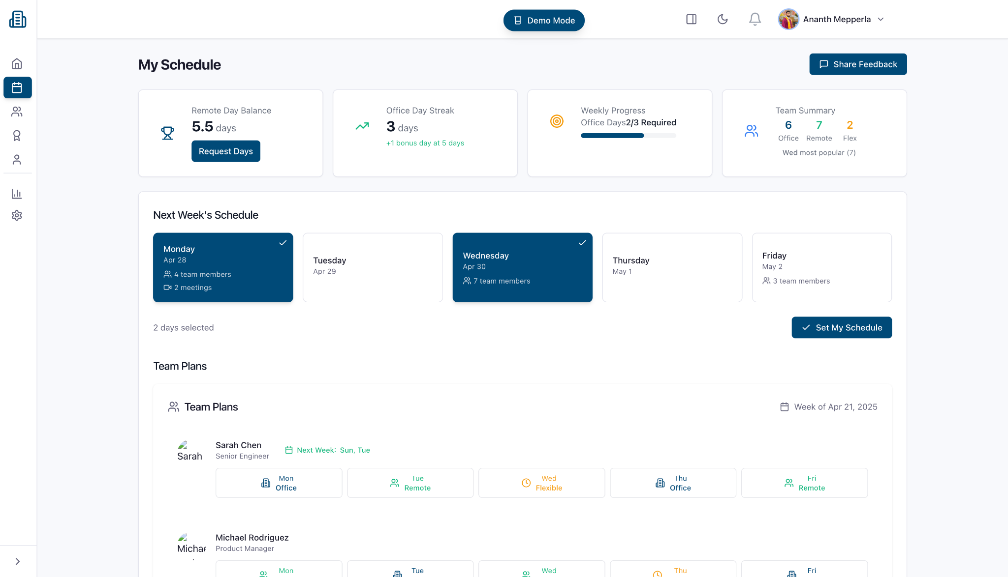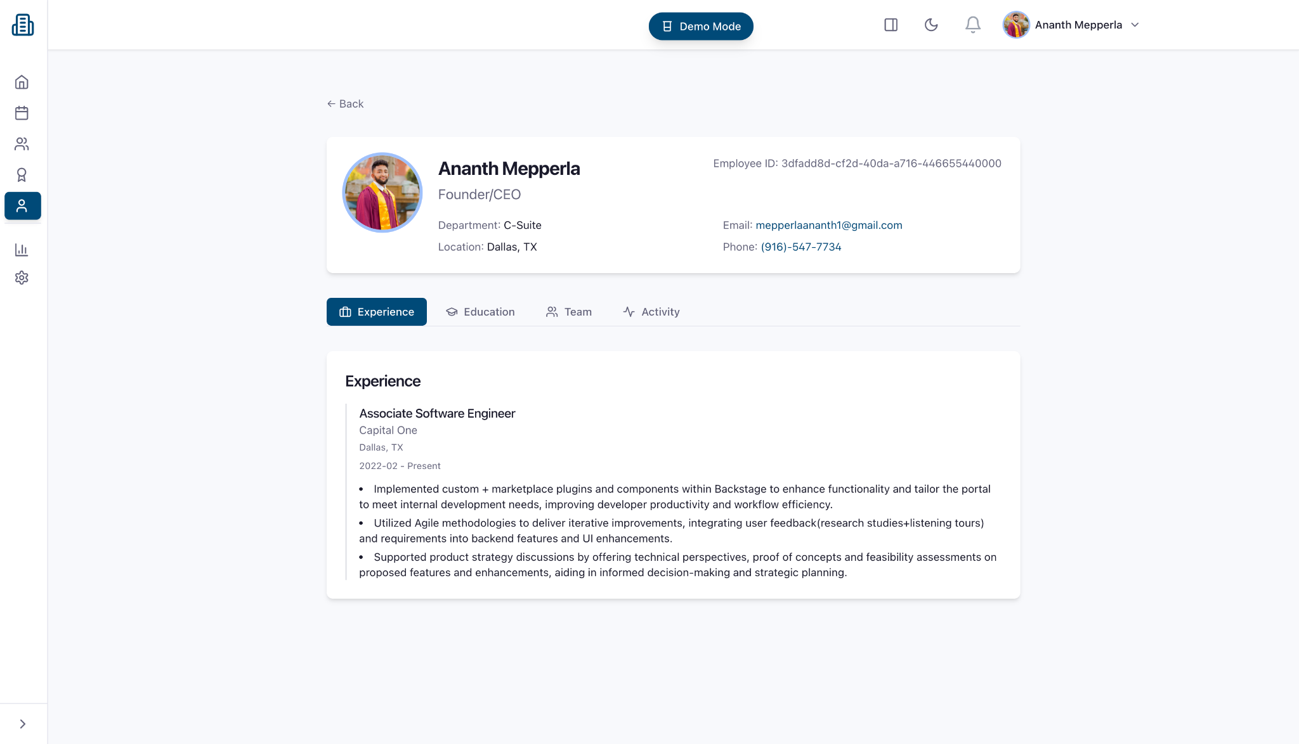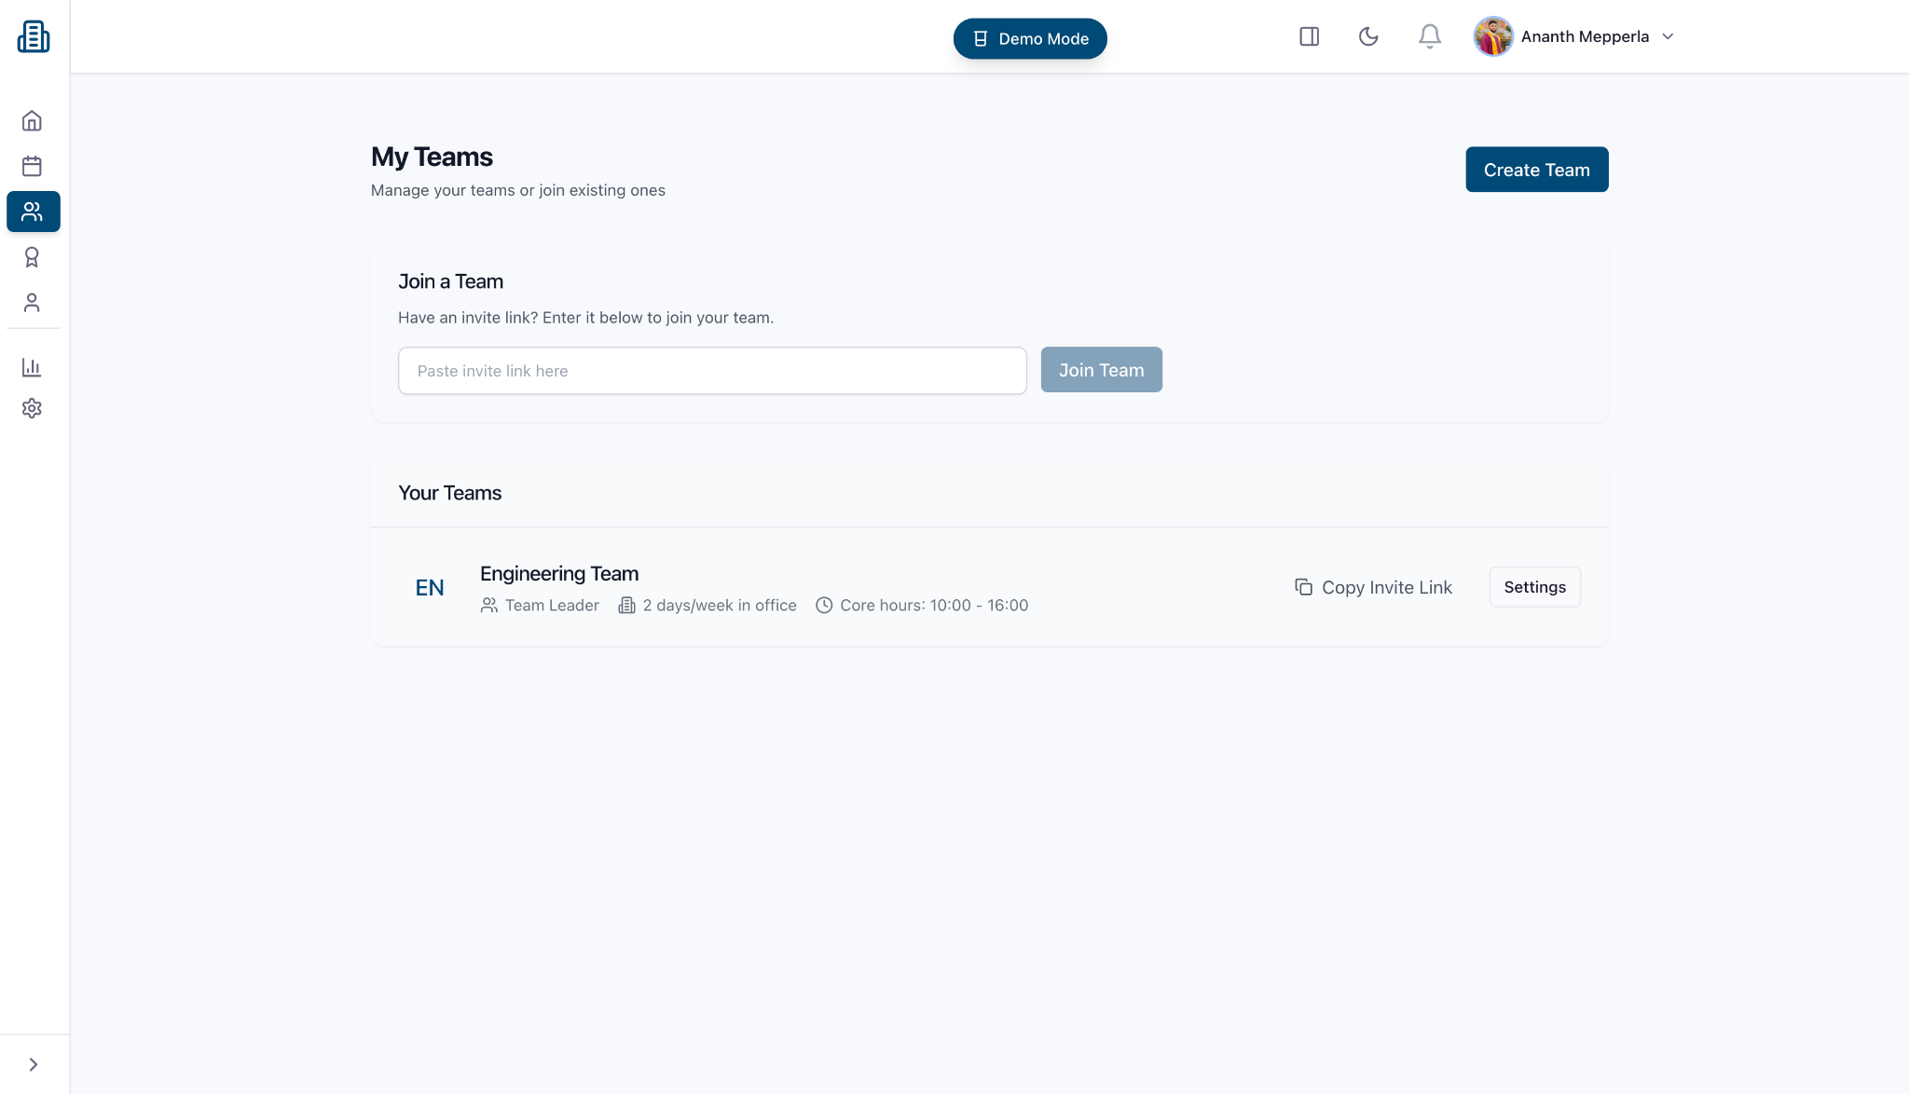

## **9. Conclusion**

Hi-Bridge offers a powerful, data-driven solution to manage hybrid workforces effectively. By incentivizing in-office participation and providing actionable insights, enterprises can unlock higher engagement, collaboration, and profitability. Lower attrition rates, improved employee well-being, and increased productivity ensure that companies see measurable financial gains.

With proven cost savings of up to $11,000 per employee annually, companies can reallocate budgets to innovation, talent development, or growth initiatives. Hi-Bridge ensures that companies not only meet their hybrid work goals but also create a culture where employees want to return to the office—not because they have to, but because they choose to.